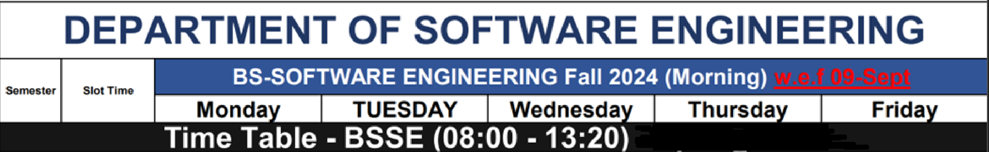
 | 0800 - 0845
 | 0855 -0945 | Student Counseling Hours | Student Counseling Hours | INFORMATION SECURITY  SE6 B  Room 56 | Computer Networks  IT3  Room 49 | INFORMATION SECURITY  SE6 B  Room 8
 | 0950 -1040 |  |  | INFORMATION SECURITY  SE6 B  Room 56 | Computer Networks  IT3  Room 49 | INFORMATION SECURITY  SE6 A  Room 49
 | 1045 – 1135 |  |  | LAB  Computer Networks  IT3  SE LAB II
 | 1140 – 1230 |  |  |  | INFORMATION SECURITY  SE6 A  Room 49
 | 1230 – 1320 |  |  |  | INFORMATION SECURITY  SE6 A  Room 49
AFTERNOON

 | 130 – 315 |  | CN LAB  SE 5 A  SE Lab 3
 | 330- 440 |  | CN  Associate Degree  Room 58
 | 445 -600 |  | CN  Associate Degree  Room 58 | CN  SE 5 A  Room 49
 | 605-720 |  |  | CN  SE 5 A  Room 49

